The collection of hand painted shells and other Ukrainian artwork.
The shells and other military gear elements come from various areas of Eastern Ukraine where the Ukrainian army is fighting against russian invaders. Many of them are remnants of the fighting in the Bakhmut area, but some come from other sections of the frontline. All elements of military equipment come from the Ukrainian side.
Ukrainian soldiers collect shell casings and other elements remaining after firing the missile, as long as they are not destroyed. They give these items to volunteers who visit military units bringing essential supplies. These elements, being remnants of the weapon, are no longer a threat. They are not considered part of the weapon under the law, too. Once decorated by artists, either professional or amateur, they become pieces of art.
Volunteers often hand these pieces of artwork to people and organizations supporting the Ukrainian army and civilian population. By such gifts they express their and Ukrainian society’s gratitude. Volunteers also sell this kind of artwork at charity auctions around the world in order to raise funds to purchase equipment for the army: from food or clothing to specialized equipment such as drones or off-road vehicles.
Such works of art are not only unique souvenirs from battle sites of Ukraine. They are also testimonies of the commitment and sacrifice of the Ukrainian society. They show how different people, from children through single mothers and physical workers to professional artists, discover their talents and, on their own initiative and internal motivation, create art that helps serve noble goals.
The works were collected from various artists by volunteer Vasyl Khmil based in Lviv. Then, Ukrainian diplomats transported them to Poland during their trip. From there, the Gentes foundation from Krakow transferred them to auction houses in Western Europe.

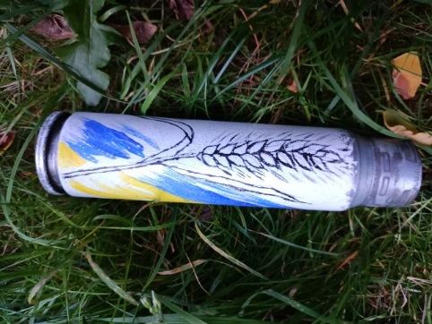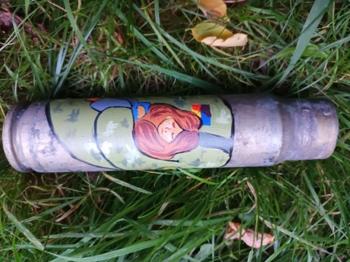
These shells were painted by a young lady, resident of Lviv, privately the wife of Vasyl Khmil's godson. She is currently on maternity leave with her small child. Even though she has no artistic education and has never been involved in art before, she did not want to sit idle. So she decided to help the Ukrainian military by painting shells in self-invented patterns, which she then donated to charity auctions.
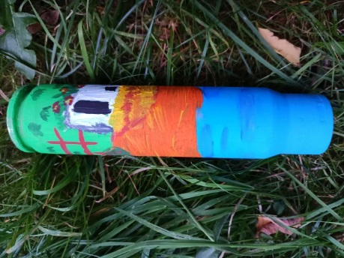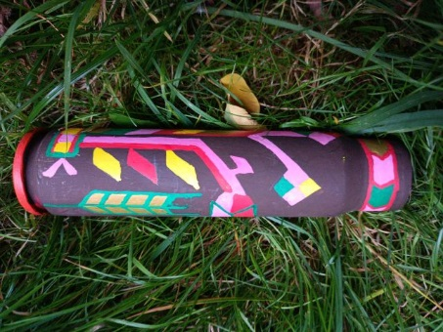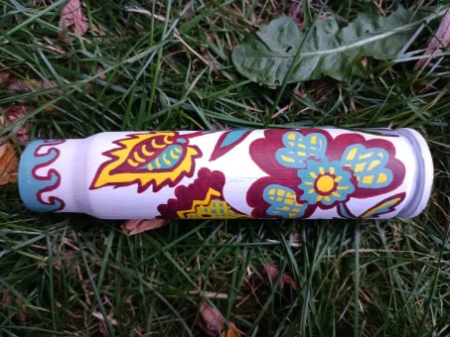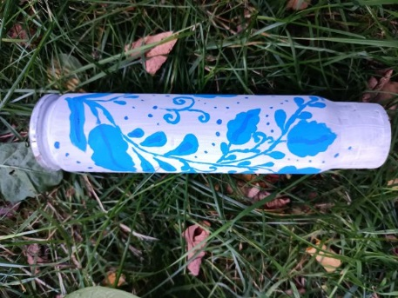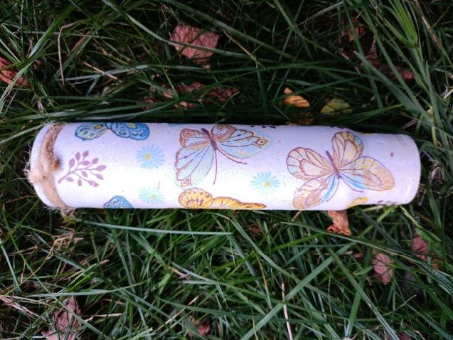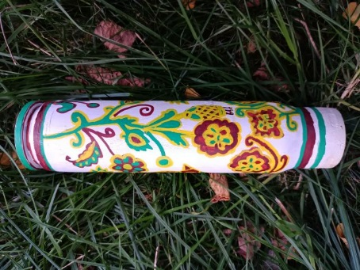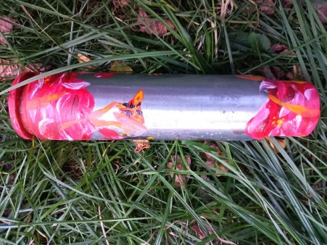
These shells were painted by children from a primary school in Lviv, Sykhiv district, as part of art classes. It is a primary school, children are from 7 to 13 years old. In Ukraine, many children participate in extracurricular activities. They are organized by schools and are free of charge.
Wasyl Khmil received shells from volunteers returning from the frontline. He knew that the children at the local school would love to help the military. Of course, he first met with the school headmistress to show the items and ensure that they did not pose a threat to children. After obtaining her permission, the shells were brought to art classes. The children responded enthusiastically to the idea of painting them in order to support the military. They showed great motivation and creativity by painting their own motifs on the shells.

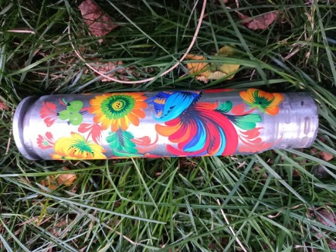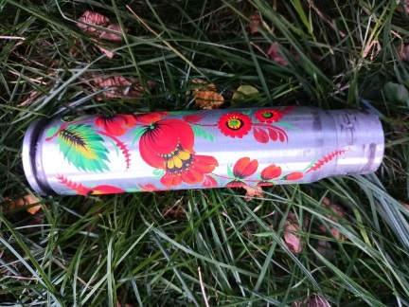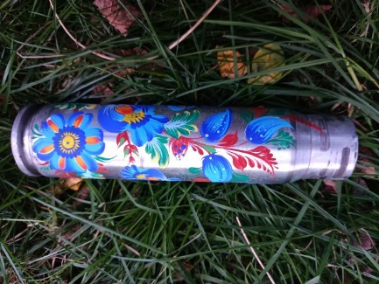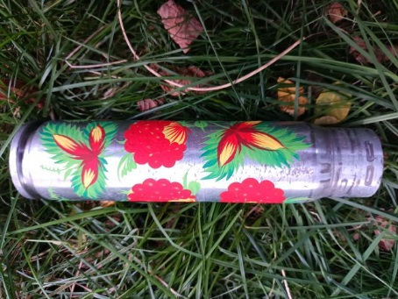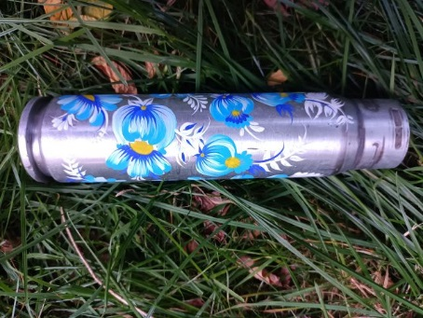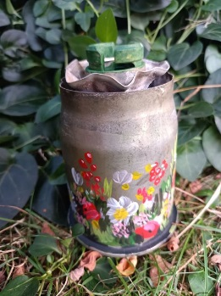
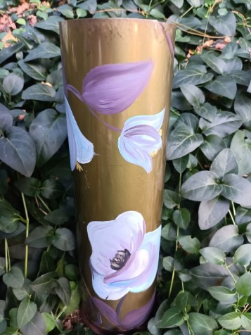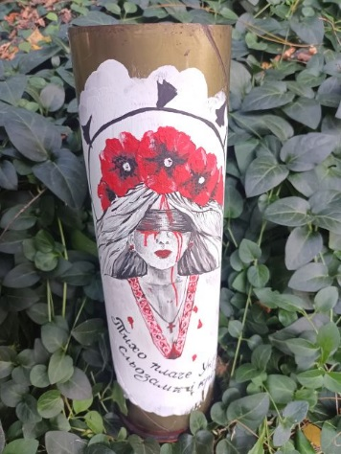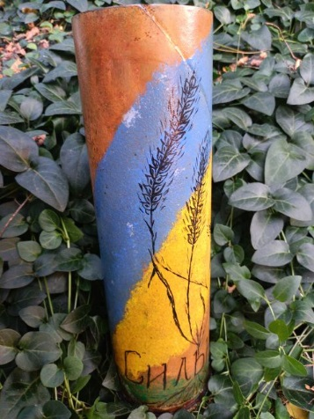
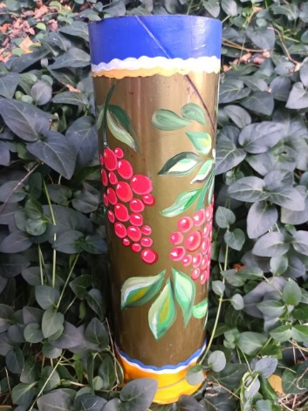n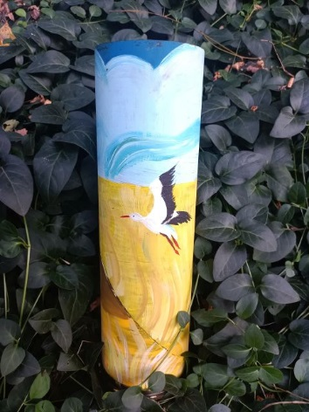
All these shells were decorated by students of College of Decorative and Applied Arts after I. Trush in Lviv. This is a high school with an artistic profile, well-known in western Ukraine.
Students of this school create a lot of art and handicrafts, which they use to support the Ukrainian army. This is their own patriotic initiative. They work independently, after school hours, and this volunteering does not affect their grades at school or provide any direct benefits to them. However, it allows them to support the Ukrainian army that defends the integrity of their homeland.

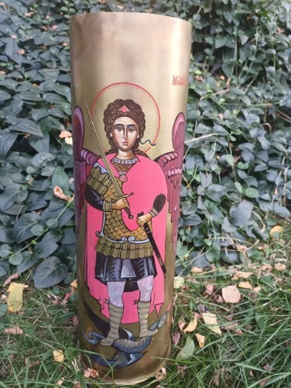
The author of this painting on artillery shell have chosen to remain anonymous. What we know is that the artwork comes from the College of Decorative and Applied Arts after I. Trush in Lviv. The high artistic level of the artwork proves that the author must have been one of the school's professors. But we may never get to know who exactly it was. She or he joined the initiative of college students and decided that her or his piece or art would support the Ukrainian military, not the author’s fame.

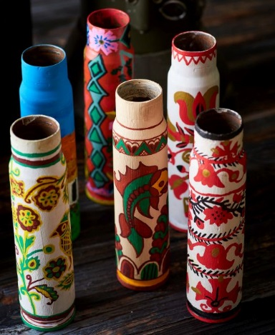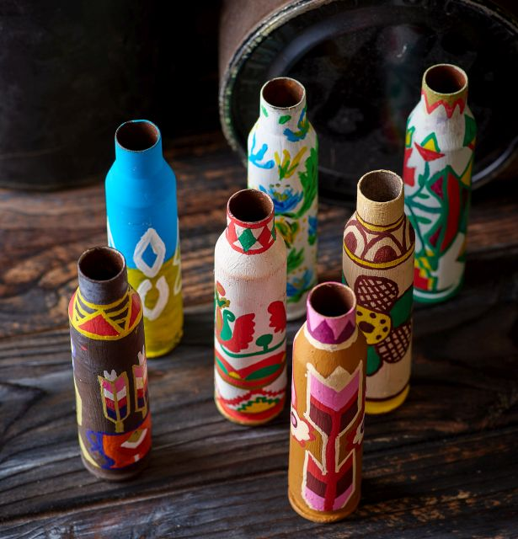
The small shells were painted by the children aged 7 to 13 being students of the local primary school at Pidbirtsy village near Lviv. Painting them was part of extracurricular art classes organized for children by the school. When children learned that they would be painting shells in order to support Ukrainian Army they felt very excited. Althoudh it reuired a lot ow work and patience they painted many shells.

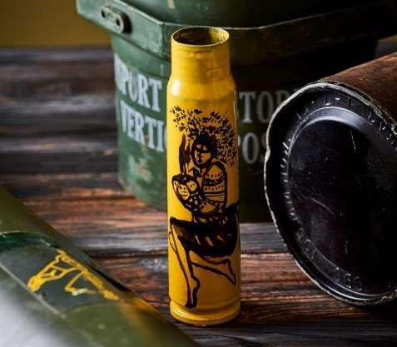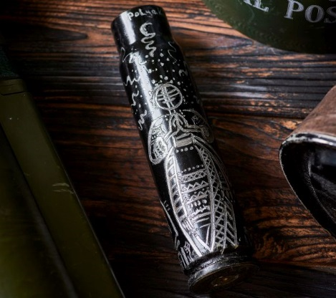
These shels were painted and engraved by the grownup Ukrainian girl, having no prior education in arts. She was motivated by patriotism and the desire to support the Ukrainian Army. She chose to remain anonymous. The motifs of her artwork explore the topic of femininity. The black shell’s motive refers to traditional Ukrainian dolls called motanka.
Collection or artworks by Oleh Deshchytsia, the professional artist based in Lviv. He mainly works with painting, but he also creates works in other fields of art. Oleh Deshchytsia is a a member of National Union of Artists of Ukraine (Національна спілка художників України).
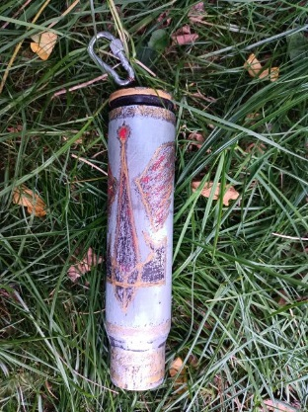
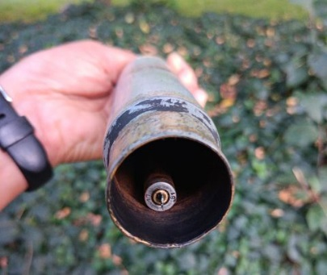
the bell made of two shells

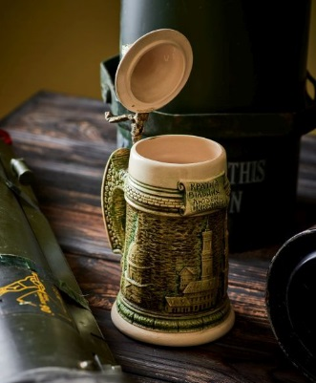

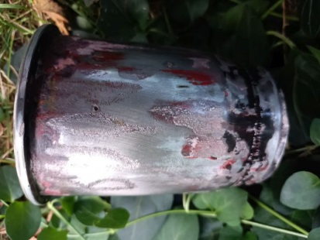

traditional beer mug

engraved shell of a grenade launcher
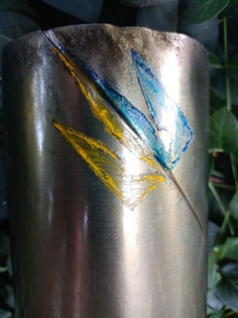
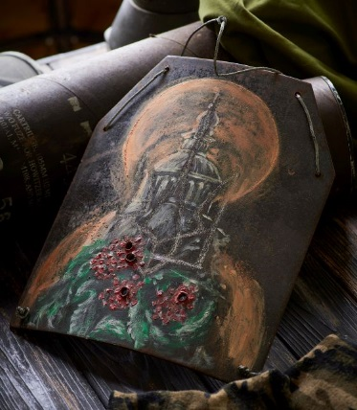

painted ballistic plate
shot during tests
(no soldier ever wore it
or was shot)
engraved and painted artillery shell
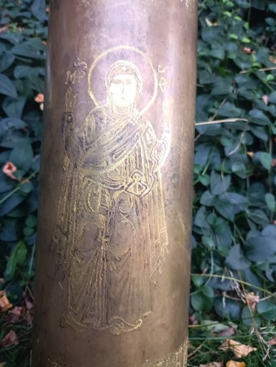

This engraver on an artillery shell shows Oranta - a depiction of Holy Mary praying in a standing position with raised arms, typical of Ukrainian medieval religious iconography. This piece of art by Oleh Deshchytsia is a reference to the famous and very important for Ukrainian tradition and identity 11th-century painting. The original painting is located in the cathedral of St. Sophia in Kyiv. It depicts Our Lady, patron saint of Ukraine, raising prayers for the country.
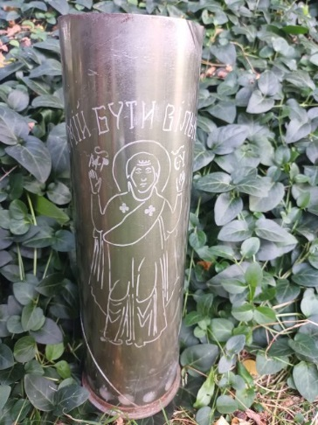
This piece of artwork on artillery shell was created by Vasyl Khmil himself. It is a reproduction of Oleh Deshchytsia engraver on another shell that shows Oranta – the Holy Mary praying in a standing position with raised arms as she was traditionally depicted in Ukrainian medieval iconography.
The artwork was created using the sand engraving technique based on a drawing copied from the original work of Oleh Deshchytsia. The text says “dare to be free”.

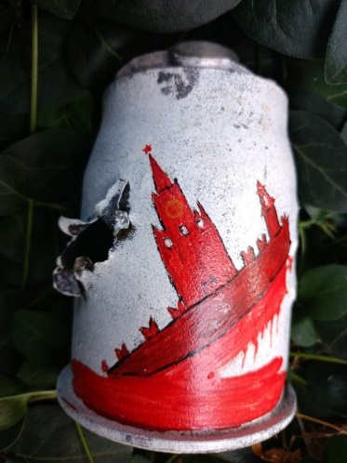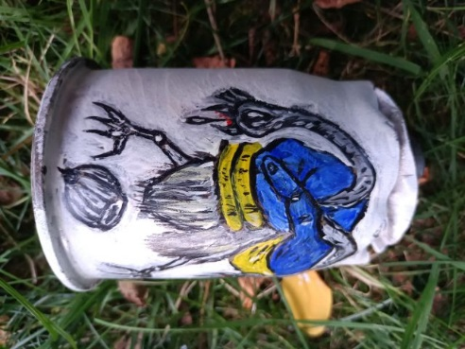
These two grenade launcher shells were painted Vasyl Khmil’s friend would like to remain anonymous. What we know about him is that he has no education in arts and he works in construction industry. He would like to volunteer for the Ukrainan Army, but he cannot serve due to health reasons.
When he saw various shells brought by Mr. Khmil to Lviv to be painted, he decided that he also wanted to use his creativity in order to support the Ukrainian Army. So he chose few grenade launcher shells and painted on them self-created motifs related to the destruction of russia.

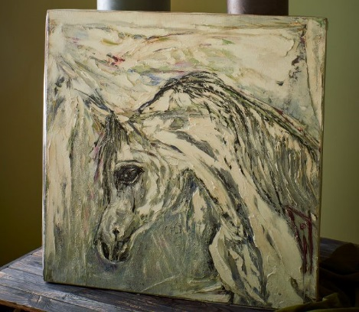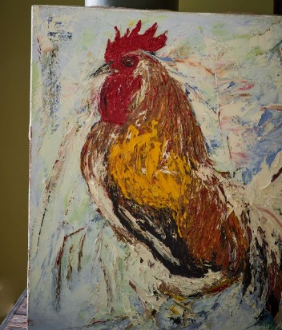
These oil paintings were painted by Iryna Prokhorovytsch, the professional Ukrainian. She lives in Lviv and in her private life she is Oleh Deshchytsia’s wife.

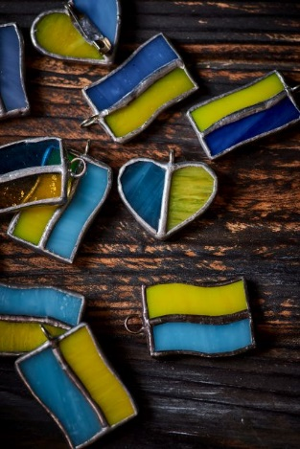
Pendants in colours of the Ukrainian flag were created by children aged from 7 to 13 years being students of the primary school in Sykhiv district of Lviv. It was a voluntary work done as a part of extracurricular art lessons organized at this school. The pendants were made to support fundraising for Ukrainian Army.

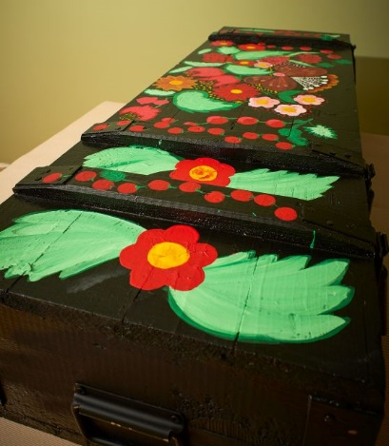

The ammunition box was painted by a friend of Vasyl Khmil, Mr. Vitaliy who decided not to reveal his family name. The only facts we know about hi mare that he has his own stonemasonry company and that he has no formal education in arts. In his work, he referred to folk floral patterns used to decorate chests in traditional Ukrainian rural huts.

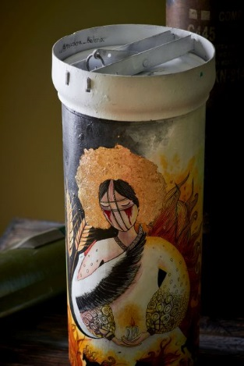
This shell was painted by one of Ukraine’s renowned female bloggers. But we will never know who exactly she was. As many other authors creating this kind of artwork designed to support the Ukrainian Army, she also chose to stay anonymous.
Motives of the painting refer to the traditional motanka. Motanka is a doll, made of layers of material placed one on top of the other and tied with a string, traditionally supposed to bring good luck. Also the stork present on the picture is a symbol of love and hapiness in Ukraine.

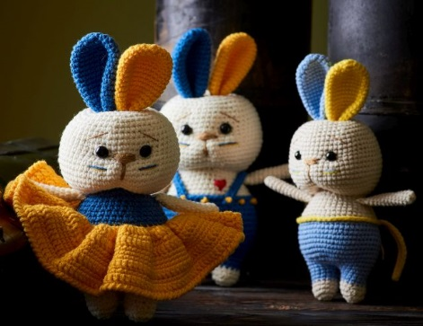

Bunny mascots in the colors of the Ukrainian flag were crocheted by Ukrainian women volunteers.

